DAD 220

Professor Allauddin

Zaccheus Everett

13 August 2023

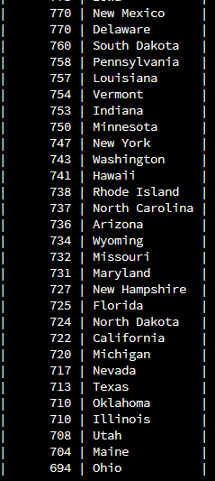

Here I have retrieved the amount of product returns that are not in pending status by state. Here we can see that in the states that we service, there are a minimum of 666 returns per state. Massachusetts has the most returns with 923 returns. With this data we can see where our returns are coming from, however, it does not provide a sense of scale. Without further data it is hard to tell whether a minimum of 666 returns per state is significant or not. Still, with the highest number of returns coming from Massachusetts, we may want get feedback from those customers to attempt to understand their concerns and expectations with the products.

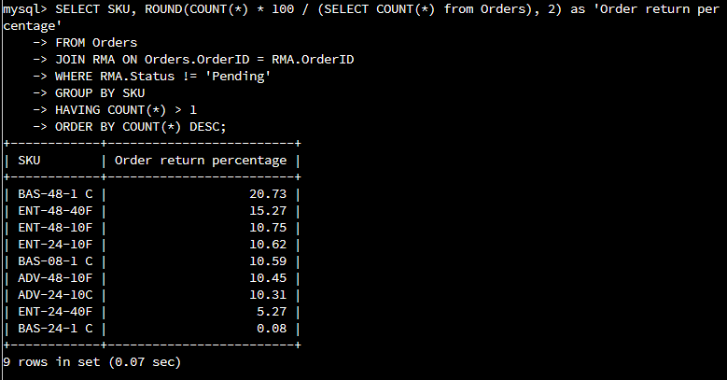

Here I have retrieved the percentage of returns by SKU against all our orders so that we can get a scale of how many of our orders are getting returned. Again, the data gathers is for all returns that are not in pending status. Added up we can see that 94.07% of all orders are getting returned which is an extremely high amount. Additionally, we can see that SKU BAS-48-1 C is the leading return while BAS-24-1 C is significantly lower in returns than every other product.

While this data allows us to see the number of returns against our entire inventory, it does not allow us to see the percentage for the item itself. For example, BAS-24-1 C accounts for only 0.08% of our total returns. However, this may be because the item does sell well and there were only a few customers who could return one. With further data we can verify that case and if it is not, we may want to reduce the sales of BAS-48-1 C and promote BAS-24-1 C to lower the number of returns.